Controlling a Mobile Robot with Visual Prolog

Tatyana Volkova

Russian State University for the Humanities, Intelligent Systems Department, and
Robotics and Artificial Intelligence Laboratory of the State Polytechnic Museum,
Moscow

Abstract. This work describes one simple model of mobile robot behavior. It demonstrates one of possible ways of using a communication RS-232 program written by Ben Hooijenga. This robot was created at the Robotics and Artificial Intelligence Laboratory of the State Polytechnic Museum.

Introduction

This paper describes a practical realization of a simple declarative model for controlling a technical object – a mobile robot, which was built at the Robotics and Artificial Intelligence Laboratory of the State Polytechnic Museum under Technics PhD Valery Karpov and Technics PhD Dmitry Dobrynin. Students and schoolchildren develop and program their own robots there. As an AI student I participate in this laboratory and would like to present my first robot (see Fig.1)
Architecture of the system

The model of the robot’s behavior is similar to the behavior of a living creature.

The system can be divided into the low-level actions, which are processed by the robot himself, and the high-level actions, which are suggested by a Prolog program on a stationary computer.

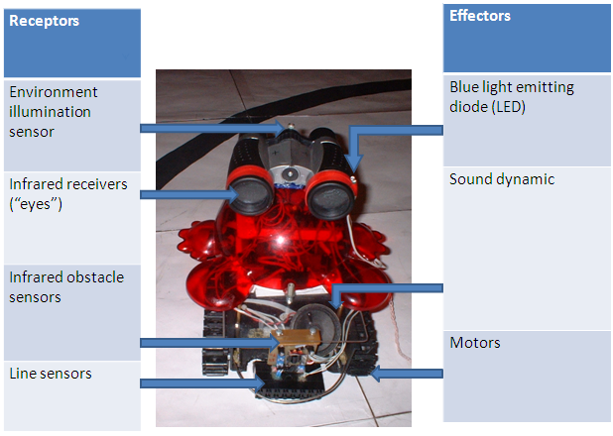

Figure 1. Robot’s receptors and effectors

Low-level actions include: unconditional reflexes (evading an obstacle, getting frightened by a sudden light, following the path on the floor, following an IR emitter, defining whether he is at home (“home” is a grey spot on the floor)), simple actions (lighting a LED, crying), decomposition of high-level commands to low-level ones. All low-level actions are programmed into the robot’s microcomputer on C language.
High-level commands are planning, guiding, database maintaining and the world map building. See Fig.2.

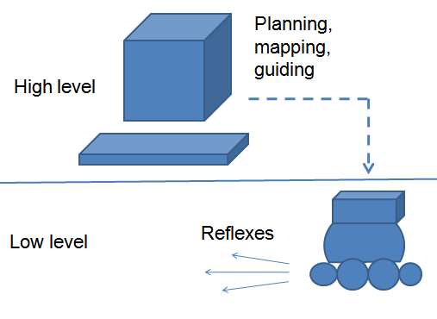
Figure 2. Two levels of robot’s control

If robot doesn’t receive any message from the computer during several seconds, he
considers himself “lost” and wanders
randomly, only reacting to the environmental exposure with his reflexes. When the computer takes control, robot becomes passive and obeys the computer.

The advantage of such system is that even in the case of a mistake or a controversial command from computer, robot can still evade dangerous situations because of unconditional reflexes.

Combination of simple low-level reflexes and complex high-level command sequences gives us the model of a living organism. The idea of hierarchy in control systems is quite old, but not widely spread in robotics. Among the latest implementations, [Karpov, 2007] must be noted.
The structure of the robot
The robot is an autonomous mobile device, driven by a microcontroller, which has clock rate 7 MHz and flash memory of 8 Kb, which is not enough for a complex program.
See the overall scheme of the system on Fig.3

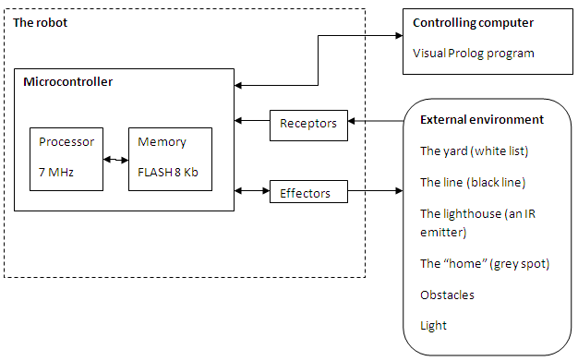

Figure 3. The model of the system (adopted from [Gaaze-Rapoport 1987])

Robot has different sensors (receptors): environment illumination sensor, infrared receivers (“eyes”), infrared obstacles sensors, line photo sensors; effectors, which influence the environment: motors, light-emitting diode, sound dynamic.

Robot sends information about his movements, obtained by encoders on both driving wheels, so we can know the length of movement vector and its angle relatively to the robot’s starting position. Changing polar coordinates to Cartesian, computer tries to draw robot’s position on the map and assert the coordinates of all significant objects to the database to use them later for navigation.

Communication program

To establish a connection with robot, a terminal program on Visual Prolog is required. Ben Hooijenga wrote such program under VIP 7.1 CE, it’s available on PDC forum and on Visual Prolog Wiki.

The program is easy to apply and has a convenient GUI for setting all the parameters. The program makes it possible to send and receive bytes via RS-232 interface and process communicstion events. A declarative system for the robot was added to this program.

To make a communications channel between robot and computer, a protocol was developed.

Description of the protocol

To avoid synchronization problems, a firm scheme involving timer was specified.

Each 100 milliseconds a communication act takes place. Computer sends a command of sensors polling, encoded with one byte. Robot receives it and answers with two bytes, first of which is the robot’s state and information about his movements. Second byte represents signals on robot’s sensors. Computer decides what robot should do next, and answers with a command, typically, of one byte. See the scheme on Fig. 4

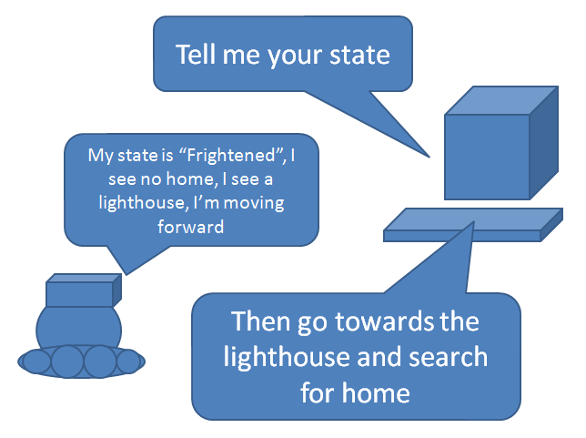

Figure 4. Example of communication

A fragment of the protocol on computer’s side

Here is the code of timer interruption, in which communication between robot and computer takes place.

% timer routine on each 100 milliseconds
predicates
onTimer : window::timerListener.
clauses
onTimer(_Source, _timer):-
% start communication
send("TELL_ME_YOUR_STATE"),
% get an answer from the robot about his state and movements
readStateAndMovements(),
% get signals on sensors
readSensors(),
% If autocontrol (base of rules) is on
if auto_control=true() then
% get a command using a rule from base
(rule(CommandToRobot),
% send the command
send(CommandToRobot),
fail; % backtrack to try all the rules
succeed())
end if,
% repaint the map on the screen
refresh_map().

All the read predicates have similar structure. For example, below is a predicate which receives the 2nd byte from the robot (a Boolean vector of signals on sensors) and decodes it, making a map.

predicates
readSensors: ().
clauses
readSensors():-%Create a binary massive 1 byte length
BinaryRead = binary::create(1),
% Read 1 byte (predicate for comdevice,
written by Ben Hooijenga)
BytesRead =
comdevice:readfile_overlapped(
BinaryRead,
binary::getSize(BinaryRead)),
%convert binary to a list of bits
SensorsList = bit::bitSplit(
binary::getIndexed_unsigned8(
BinaryRead, 0)),
foreach
Bit = list::getMember_nd(
SensorsList)
do
% decode the signals and assert the info
into database
if decodeSensorsSignals(Bit,
Object), ! then
% add an object, detected by sensors, to
the world model
placeOnTheMap(Object)
end if
end foreach.

Decoding the sensor signals simply means interpretation according to the bases of facts which are written in both robot’s and computer’s memory.
Here is a fragment of such a base of facts.
class facts
decodeSensorsSignals: (unsigned8, string ObjectType).
clauses
decodeSensorsSignals(128, "home").
decodeSensorsSignals(64, "line").
decodeSensorsSignals(32, "light").

And here’s a fragment of base, from which commands to the robot are encoded:

% Base of facts - commands to the robot
class facts
command: (unsigned8, string).
clauses
command(0x10, "STOP ").
command(0x20,
"TELL_ME_YOUR_STATE ").
command(0x30, "GO_FORWARD ").

The base of rules

The base contains rules such as:

predicates
rule: (string Command)
nondeterm (o).
clauses
% If you are frightened and see an obstacle, turn the LED on to frighten a
possible enemy
rule("SWITCH_LED_ON_TEMP "):-
state("Frightened"),
obstacle_sensor_active("FarIRSensor").
% If you are at home, turn your LED on
(rejoice) and wait one second (have a rest)
rule("SWITCH_LED_ON_TEMP "):-
state("AtHome").
rule("WAIT_ONE_SECOND"):-
state("AtHome").
% If you are still at home - go and look for line
rule("LOOK_FOR_LINE "):-
state("AtHome").

An example of interaction between robot and computer (see Fig. 5)

After being turned on, robot is moving around for some time to adjust his sensors. In the initial state robot moves randomly, until the computer tells him to look for the line. Having found the line, robot starts to follow it.
If a bright flash of light frightens robot, he “cries” and “panics”, moving around randomly, till the computer orders him to turn LED on and follow towards the lighthouse (the lighthouse stands in the middle of “home”).
Robot looks for the lighthouse and goes towards it, checking if he is already at “home”. If robot reaches home, a command from computer tells him to return to the line.

% from the computer
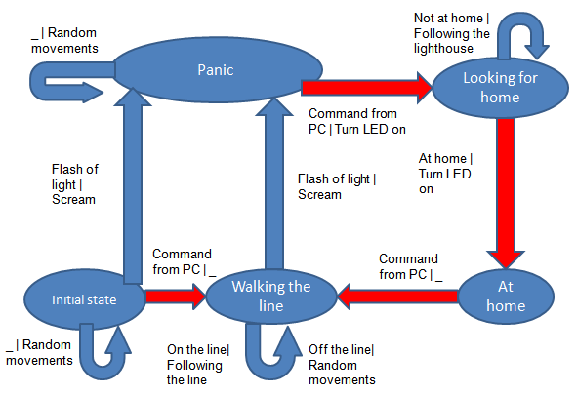

Figure 5. The model of robot’s behavior. Red transitions can only be made after a computer’s command and they do not contain in robot’s memory.

Plans

Now we are working on next projects. Among our projects are continuation of work on museum robot-excursion guide and building more complicated robots. My second robot will be a robot-navigator.

References

[Gaaze-Rapoport, 1987] Gaaze-Rapoport M.G., Pospelov D.A. From ameba to robot: models of behavior. M.: Nauka, 1987 [In Russian]

[Karpov, 2007] Karpov V.E.. Imprinting and central motoric programs in robotics //IV International theoretical and practical conference "Integrated models and soft computing in artificial intelligence (28-30 may 2007). Conference proceedings. M.: Fizmatlit, 2007, 1, p.322-332 [In Russian]

Dobrynin D.A., Karpov V.E. Modeling some adaptive behavior forms of intellectual robots. //Information technologies and computing systems №2, 2006, p.45-56 [In Russian]

